Homework
In the coming weeks, homework will be set on a Wednesday via SeeSaw and due the following Tuesday. Homework tasks will consist of a TT Rockstars activity where the children may be asked to complete a certain amount of minutes or play a certain amount of games. There will also be a task linked to our current learning journey for the children to complete and upload back to SeeSaw. Red tasks indicate that they are compulsory but tasks in blue are optional. On top of homework, we ask that children are reading daily and that it is recorded in to their reading diaries.

Growth Mindset
Growth mindset is the idea that through practise, development and hard work everyone can develop and there is no such thing as fixed ability. This is the basis of all learning in Woodpecker Class and throughout our whole school. We want all children to adopt a growth mindset attitude and have a positive approach to all aspects of learning. By promoting a growth mindset approach, it allows all within the classroom to display an optimistic and enthusiastic learning attitude, developing their brain and learning attitudes in a positive light. We will continue to talk about growth mindset throughout the year helping us to develop into learning experts!

Contacting Us
Please feel free to contact us using the Woodpecker Class email below and we will get back to you as soon as we can.
woodpeckerclass@lavant.w-sussex.sch.uk
Alternatively, feel free to speak to myself or any of the Woodpecker staff team on the playground to pass on information.

If the matter is more urgent please contact the school office on
01243 527382.

We are looking forward to a great year ahead alongside your children!

Kind Regards,
Mr J Worne



Lavant C.E. Primary School

Woodpecker Class Year 3/4
Curriculum outline - AUTUMN TERM 2024

TERM DATES
TERM ENDS: Friday 20th December
HALF TERM: Monday 28th October – Friday 1st November
INSET DAY: Monday 2nd September, Monday 21st October

Welcome back to a new school year! We all hope you had a fantastic summer and got plenty of rest. The following newsletter will outline all of the exciting learning opportunities in store for the autumn term ahead.

Our First Learning Journey

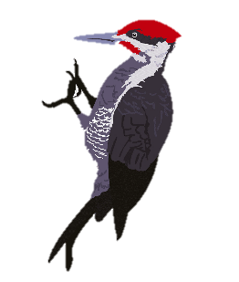
Our first learning journey ‘Welcome to Woodpeckers’ will show children what it means to be a learner within Woodpecker Class and Lavant Primary School as a whole. It is also an opportunity to re-introduce class expectations and create our class charter for the year. Throughout this learning journey, the children will be working collaboratively with classmates in a number of team activities to familiarise them with their peers and new teachers.

Other learning journeys this term
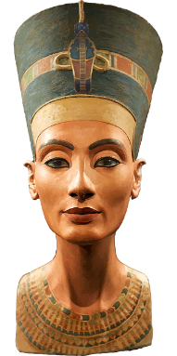
Over the course of this term, the children will tackle the different curriculum areas through a variety of engaging learning journeys. In Healthy Humans, the children will learn about the different functions of the skeleton and other important features such as muscles, the digestive system and teeth. This will be followed by a learning journey all about rivers and the water cycle, where geography will be the main focus. To begin the second half of autumn term, the children will travel back in time to Ancient Egypt and become inquisitive historians, learning about one of the Earth’s earliest and most impactful civilisations. Our next science based learning journey, Let’s Rock, will focus on the scientific layers that make up our planet, the formation of rocks and the fossils trapped within. To round of the term, the children will be creating their own Christmas themed poetry with accompanying music in Twas the Night before Christmas. Our autumn term will also feature a whole school celebration of reading during BookFest week.

Maths
Our first mathematical concept of the year is place value with the intention to create a very strong foundation for the units ahead. We will also look at simple addition and subtraction before moving on to more formal written methods. Our attention will then focus on multiplication and division where we will begin with the fast recall of facts before building a core understanding of what the two operations actually entail alongside their definitions. The term will be rounded off with the learning of length, perimeter and area, and their application to worded problems. The practise of times tables and general maths fluency will be taught throughout the year. Children in year 3 are expected to know their 2, 3, 4, 5, 8, and 10 times tables by the end of the year, and children in year 4, all tables up to 12 including the related division facts.

Modern Foreign Languages (MFL)
French lessons will be taught weekly throughout autumn term. The children will start by learning basic greetings and emotions before exploring what a school day might be like in France along with the various French classroom terminology.
Physical Education (P.E.)
On Wednesdays, children are asked to come to school wearing their PE kits as we will have a sports session from our specialist PE provider. This is an excellent chance for the children to receive quality training in a variety of sports, starting with football. In addition to this, children in KS2 will receive weekly swimming lessons as part of the National Curriculum requirement. 15 minutes of fitness will continue throughout the year. Therefore, Children are asked to have a pair of trainers in school every day.

Computing
Our computing sessions will see the children focusing on the computing basics. We will look at how to use the computers appropriatly while also teaching the core skills that will be needed for the rest of the term. After half term, we will be making our own digital comics.

Music
Music will be taught on a Wednesday afternoon by Mrs Upjohn. This term the children will undertake a unit of work that introduces the language of music through playing the glockenspiel. They will focus on learning how to play and identify various notes, follow musical notation to play some simple tunes and create some of their own compositions before performing them.


Religious Education (R.E.)
For the first half of term, our RE focus will be on the creation story and its importance to Christians today. Our focus will then shift to the core Christian concept of the Holy Trinity and how those beliefs are demonstrated in bible, the church and in way we live.

