Top Tips to help your child learn their spellings
Here are some suggestions to help your child learn their spellings. You may find different ways will help with different words.
Highlight the tricky bit.
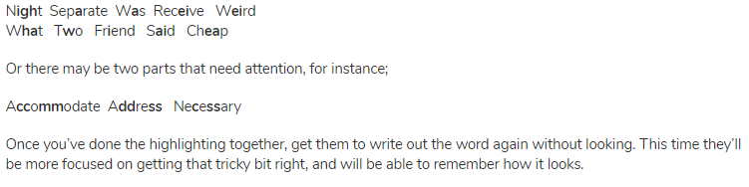
Make the spelling stick by finding little ways to help.
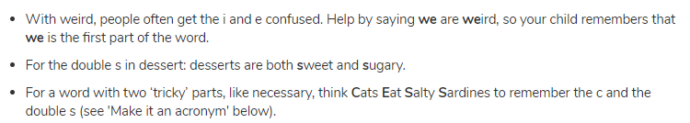
Break it down
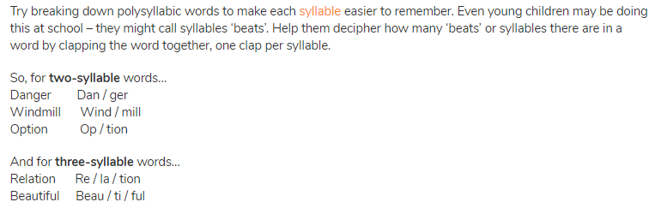
Look, Cover, write and check
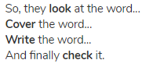
Create a picture
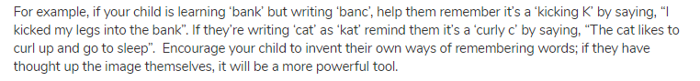

Make it acrostic/mnemonic
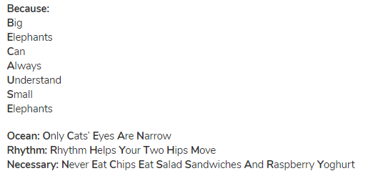
In the palm of your hands
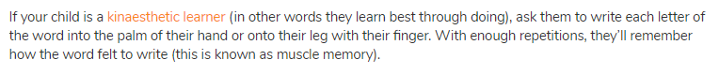
Sing the word
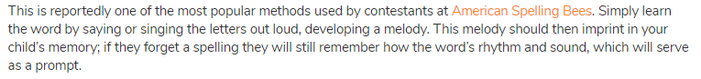
Pop the words around the house or up the stairs
The more your child sees their words the more likely they will have a visual memory of them.
Rainbow Write them
Write them out in as many different colours as possible!

